**PRACTICAL NO.04**

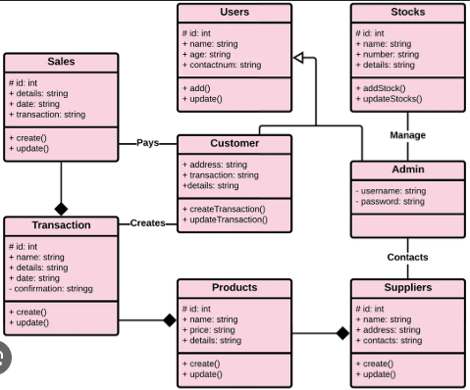

**Inventory Management System UML Diagrams**– are diagrams formed to design the structure and behaviour of the project. These UML Diagrams were used to visualize the possible users, processes, activities and sequence of events in Inventory Management System. Its purpose is to analyse, understand and know the needs of the project before developing it.

UML diagrams are diagrams based on the UML (Unified Modelling Language) that is used to visually describe the Inventory Management System including its major actors, roles, actions, artifacts, or classes, in order to better understand, edit, maintain, or document information.

**Key Actors:**

* **Admin:** Manages the entire inventory, updates stock, processes orders, and generates reports.
* **Customer:** Purchases items, views available stock.
* **Supplier:** Supplies inventory items.
* **Warehouse Staff:** Updates inventory stock when new products are received or shipped.

**Use Cases:**

* **Manage Inventory:** Admin can add, remove, or update products.
* **Track Stock Levels:** Admin or Warehouse staff can view current stock levels.
* **Order Products:** Customers can place orders.
* **Receive Products:** Warehouse staff can update inventory when new items are received.
* **Generate Reports:** Admin can generate reports based on stock, sales, and other metrics.

**Main Classes:**

1. **Product**
   * Attributes:
     + Product id: int
     + name: String
     + description: String
     + quantityInStock: int
     + price: double
   * Methods:
     + add Product ()
     + update Product ()
     + remove Product ()
     + checkStockLevel ()
2. **Order**
   * Attributes:
     + Order id: int
     + date: Date
     + customer id: int
     + total Price: double
   * Methods:
     + place Order ()
     + update Order ()
     + cancel Order ()
3. **Customer**
   * Attributes:
     + Customer id: int
     + name: String
     + email: String
     + address: String
   * Methods:
     + create Account ()
     + update Account ()
     + view Orders ()
4. **Supplier**
   * Attributes:
     + Supplier id: int
     + name: String
     + contact Info: String
   * Methods:
     + update Stock ()
     + provide Products ()
5. **Inventory**
   * Attributes:
     + Inventory id: int
     + Product id: int
     + quantity: int
   * Methods:
     + check Inventory ()
     + update Inventory ()
     + track Inventory ()
6. **Invoice**
   * Attributes:
     + Invoice id: int
     + Order id int
     + date Issued: Date
     + total Amount: double
   * Methods:
     + generate Invoice ()
     + view Invoice ()